The First Presbyterian Church

of Port Gibson, Mississippi

Worship Service May 1, A.D. 2016

Instrumental Prelude Mrs. H.N. Gage
Introit The Choir
Welcome and Announcements
The Doxology No. 572
Invocation and Lord’s Prayer
Responsive Reading No. 604
Hymn of Praise (All) No. 23
The Apostles’ Creed (Front of Hymnal)
The Gloria Patri No. 576
Time for the Children/Minute for Mission
Hymn of Meditation (All) No. 439
****
Silent Prayer and Meditation
The Pastoral Prayer
Choral Response
****
Offering and Offertory Prayer
Scripture Hebrews 11:1-2, 24-26 (p. 889, p. 1459)
Sermon “Living by Faith Means Living by Truth”
Hymn of Dedication (All) No. 223
Benediction
Response The Choir
Postlude

We extend our sincere welcome to our visitors.
Please come to worship with us again, soon.

CHILDREN in second grade or younger are welcome to attend Children’s Church after the Time with God’s Children.

IF YOU DESIRE TO BECOME A MEMBER of this congregation of the
Body of Christ, please speak to the pastor after the Worship Service.

A NURSERY is provided during the service.

Announcements

WE WELCOME The Rev. Vance McGee to the pulpit this morning. Vance is a graduate of the Talbot School of Theology at Biola University, and was ordained a minister in the Reformed Episcopal Church. He currently teaches Bible at Porters Chapel Academy.

A PRAYER BREAKFAST will be held at 6:30am on Wednesday in the Annex.

THE CHOIR will practice at 6pm on Wednesday in the Annex.

BIBLE STUDY will take place this week at 7pm on Wednesday and 1pm on Thursday in the Annex.

THE LIONS CLUB will serve a spaghetti supper in the Annex on Thursday May 5. Dinners include bread and salad and cost $7 per plate. Desserts will also be available for sale.

A VACATION BIBLE SCHOOL organizational meeting will be held upstairs in the Annex on Thursday, May 5 at 6pm.

OUR SPRING GRAND GULF OUTING will be next Sunday,
May 8. Come to the park pavilion at 10:30 for worship, and stay for a covered-dish lunch afterwards.

PLEASE PRAY for Nick and Amanda, as they participate in the Engage 2025 project in the Middle East. To help, make out your check to First Presbyterian Church and label it “Nick and Amanda.”

Upcoming Events

May 28 RiverPointe Dance Recital, 2 and 6pm, Vicksburg City Auditorum
June 4 Hands of Hope Trip to West Virginia
June 22-25 General Assembly, Ward EPC, Northville, Michigan
July 6 Cookout with Nick and Amanda
September 23-24 Presbytery Meeting, New Covenant Mandeville
October 2 Worship at Grand Gulf, Communion

Deacon for the Month: Jim Hynum
Tithes and offerings may be mailed to P.O. Box 517.
CD recordings of services are available. Call the pastor at 5887.

Bible Reading Schedule

May 2 Deuteronomy 11:8-21 – God Cares for All
May 3 Jonah 2:1-9 – A Psalm of Thanksgiving
May 4 Psalm 9:1-10 – Our Powerful God
May 5 Hebrews 12:25-28 – Thankful Reverence for God
May 6 Colossians 2:6-12 – Living Gratefully
May 7 Luke 22:14-20 – Giving Thanks
May 8 Luke 17:11-19 – Grateful Faith

May Birthdays

2 Janice Carter 7 Al Killingsworth
9 Shelton Headley 10 George Hay
11 Lillie Cassell 13 Natalie Cassell
14 Lydia Mae Fraley 15 Cathi Dodgen
17 Scott Harrison 20 Lem Montgomery
21 Ella Daughdrill 22 Alohi Easley
25 E.G. Nations 30 Iliahi Easley
31 Betty Gage

Church Directory

Rev. Michael G. Herrin, Pastor
Mrs. H.N. Gage, Organist

The Session

Class of 2016 Class of 2017 Class of 2018
Mr. Jim Cassell Mr. Burton O. Byrnes, II Mr. Gary Knight
Dr. Betsy Lipscomb Mr. Douglas Nasif Mr. Lem Montgomery

The Diaconate

Class of 2016 Class of 2017 Class of 2018
Mr. Jimmy Cassell Mr. Jim Hynum
Mrs. Ruth Willis Dr. Eddie Lipscomb Mr. Mack May
Mr. Mike Mikell

Presbyterian Women

Mrs. Dianne Wade, Moderator Dr. Betsy Lipscomb, Mission Representative
Mrs. Jo Ann Mikell, Vice-Moderator Mrs. Azalea Knight, Secretary/Treasurer

Through fellowship, teaching and service,
sharing the truth of Jesus Christ
with one another, with the community, and with the world.

The First Presbyterian Church

PORT GIBSON, MISSISSIPPI
ORGANIZED 1807
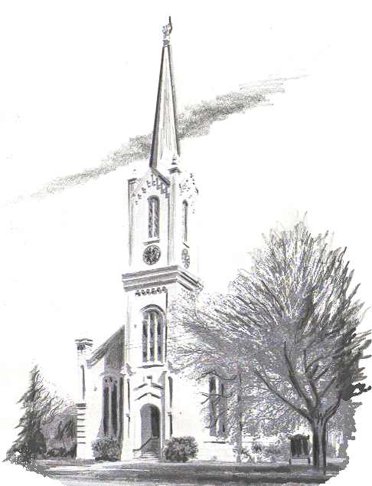

Website: www.fpcportgibson.com Study Telephone: 437-5428
Manse Address: 1101 Church Street Manse Telephone: 437-5887

